Developing Continuous SCM/CSRM Forcing Using NWP Products Constrained by Surface and TOA Observations

Shaocheng Xie¹, Richard T. Cederwall¹, Minghua Zhang², J. John Yio¹

¹Lawrence Livermore National Laboratory, Livermore, CA
²State University of New York, Stony Brook, NY

Submitted to: Journal of Geophysical Research
Submission Date:
Manuscript No:
Received:

Corresponding author address: Dr. Shaocheng Xie, L-103, ASD, Lawrence Livermore National Laboratory, Livermore, CA 94550. Tel. 925-422-6023.

Abstract. This study proposes an alternative approach to develop the multi-year long-term continuous Single-Column Model (SCM) and Cloud System Resolving Model (CSRM) forcing data from numerical weather prediction (NWP) analyses by using the variational analysis approach constrained with the observed surface and TOA measurements. In the approach, the atmospheric state variables from NWP analyses are adjusted to balance the observed column budgets of mass, heat, moisture, and momentum, rather than the NWP model-produced budgets. The derived continuous forcing data from the NOAA RUC (Rapid Update Cycle) analyses are evaluated by the ‘observed’ forcing data derived from sondes and wind profilers collected at the ARM Southern Great Plains (SGP) site using the objective variational analysis under three selected cases: a strong convective case in the ARM Summer 1997 Intensive Operational Period (IOP), a moderate synoptic-scale process dominated precipitation period in the Spring 2000 IOP, and a non-precipitation period in the late Fall 2000 IOP. We show that applying the ARM column constraints significantly improve the quality of the derived forcing data from the RUC analyses. The forcing data derived from the RUC analyses using the proposed approach agree considerably well with the observed forcing. The largest improvements are seen during precipitation periods. During non-precipitation period, the improvements are moderate because the constraints are weak in absence of precipitation. In general, the continuous forcing and the observed forcing show better agreement during the moderate precipitation period and the non-precipitation period than during the strong convective period. In SCM tests, we show that most model errors produced by the SCM driven by the observed forcing can be reproduced by the SCM driven by the continuous forcing. Even though relatively large differences are seen in the cloud related fields (e.g., the cloud amount and cloud liquid water path) simulated by the SCM forced with the two forcing data sets, the typical model errors (e.g., overestimation of the observed clouds) presented in the SCM using the observed forcing can still be detected using the continuous forcing. The close agreement with the observed forcing and the encouraging results from the SCM tests provide confidence for us in using the derived continuous forcing data for statistical study of SCM/CSRM results over long-time periods.
1. Introduction
The Single-Column Model (SCM) combined with Cloud System Resolving Model (CSRM) has been widely used in recent years to develop and test physical parameterizations used in climate models. This is largely because of the computationally inexpensive, the ability to isolate targeted parameterizations from the rest of the large-scale model, and the feasibility to validate model performance directly against available field data. To drive SCMs and CSRMs, one needs to specify time varying vertical profiles of the large-scale vertical velocity and horizontal advective tendencies of atmospheric state variables (i.e., the large-scale forcing). These forcing fields can be derived either from a sounding array existed in major field measurements (e.g., ARM and TOGA-COARE) through objective analysis or from products obtained through data assimilation at operational numerical weather prediction (NWP) centers. Randall et al [1996] gave a detailed description of the SCM and CSRM approaches and data requirements for running such models.
Most SCM/CSRM studies have been focused on evaluating the model’s ability to reproduce the detailed time evolution of important meteorology fields (e.g., temperature, moisture, surface precipitation rates, clouds, and radiative fluxes) observed during Intensive Operational Periods (IOPs) in major field measurements [e.g., Ghan et al., 2000; Xie and Zhang, 2000; Bechtold et al., 2000; Redelsperger et al., 2000; Xie et al., 2002; Xu et al., 2002]. Model errors are then linked to deficiencies in specific physical parameterizations. In these studies, the SCM/CSRM framework provides a direct link between model deficiencies and specific synoptic processes. The comprehensive set of high-frequency field data obtained from these field measurements during IOPs is used for identifying deficiencies in model parameterizations and understanding the parameterized physical processes as well as their interactions with large-scale dynamic processes. These studies provide useful insights on how to further improve the model parameterizations.
Other efforts have been recently advocated to study statistics of SCM/CSRM results [Del Genio and Wolf, 2003]. This is partly due to the sensitivity nature of SCMs to uncertainties in the initial conditions and the specified large-scale forcing [Cripe, 1998; Hack and Pedretti, 2000]. Furthermore, given the limitation of SCM/CSRM framework (e.g. the lack of effective internal feedback between the SCM and the specified forcing) and the inevitable error in the initial conditions and the large-scale forcing, it might not be realistic to expect that SCMs/CSRMs can correctly capture every individual synoptic event. Statiscal studies can help smooth out those random errors related to uncertainties in the initial conditions and the specified large-scale forcing so that one can focus on those physically important systematic errors from SCM/CSRM simulations. Noted that, for climate simulations, it is more important for a given physical parameterization to successfully simulate statistics right for the process that is being parameterized.
Statistical study of SCM/CSRM simulations requires long-term, (preferably, multi-years) continuous forcing data set. This is usually not available in the observations. A conventional way to obtain the long-term continuous forcing is from NWP model analyses. However, such forcing is largely affected by deficiencies in physical parameterizations the forecast model used in the data assimilation. Xie et al. [2003] compared the large-scale forcing derived from the ECMWF model and that from an objective analysis and found that these two forcing data exhibit significant difference over periods where surface precipitation rates were not well simulated by the ECMWF model due to potential errors in its physical parameterizations. They also showed that such differences can have large impacts on SCM simulations. These results are illustrated in Fig. 1, which compares the vertical velocity (omega) derived from the constrained objective variational analysis [Zhang and Lin 1997; Zhang et al. 2001] and the ECMWF model (Figs. 1a,b) and the impact of the two different forcing data on the SCM simulations (Fig. 1c) during a selected strong convective period in the summer 1997 IOP at the ARM Southern Great Plain (SGP) site. The thick black lines in Figs. 1a,b are the observed and model-produced surface precipitation rates, respectively. During this period, two strong precipitation events on day 2 and day 6 and a weak precipitation event on day 4 were observed (Fig.1a). Note that ‘day n’ here refers to the day between n-1 and n in the plots. For example, day 2 refers to the day between 1 and 2 in Fig. 1a. This convention is used throughout the paper. Associated with the two strong precipitation events, strong upward motions are seen in the variational analysis derived omega field. In comparison with the observations, the ECMWF model predicts much weaker precipitation and tends to trigger convection more often. Consistent with the problems in its produced precipitation, the model shows much weaker upward motions and much higher temporal variability in its derived omega field than the observed. Using these two forcing data sets to drive the NCAR CCM3 SCM with a modified cumulus convection scheme [Xie and Zhang, 2000], Fig. 1c shows that the SCM driven by the objective analysis forcing generally captures well the observed precipitation while the SCM with the ECMWF forcing largely underestimates the observed values. It actually reproduces well the ECMWF model-calculated precipitation. Detailed discussions about these two forcing data can be seen in Xie et al. [2003]. The above results indicate that the NWP derived forcing data should be used cautiously.
In this study, we propose an alternative approach to develop the long-term continuous forcing data set. This approach is based on a constrained objective variational analysis method that was developed by Zhang and Lin [1997] and was applied to process the ARM IOP data by Zhang et al. [2001]. The variational analysis uses the domain-averaged surface and top of the atmosphere (TOA) fluxes as the constraints to enforce the atmospheric state variables to satisfy the conservation of mass, heat, moisture, and momentum. Note that previous objective analysis approaches [e.g., Barnes, 1964; Lin and Johnson, 1996] typically only utilize the mass constraint. A desirable feature of the variational analysis approach is that it can significantly reduce the sensitivity of the resulting derived forcing fields to uncertainties in upper-air input data after applying these constraints, especially the heat and moisture budget constraints [Zhang et al. 2001]. This encouraging feature has led us to use a combined NWP data analysis and the variational analysis approach to derive the long-term continuous forcing data set. In this approach, the NWP analysis data are used to provide the required long-term time varying vertical profiles of atmospheric state variables and the large-scale forcing is derived from the NWP analyses using the variational analysis approach constrained with the column budget constraints obtained from surface and TOA measurements. Note that, in this approach, those state variables from NWP analyses are adjusted to balance the observed column budgets rather than the NWP model-predicted column budgets. This is an important difference between the forcing directly derived from NWP analyses and that derived from the proposed approach. Detailed description of this approach will be in section 2. In section 3, we will briefly describe the NOAA RUC (Rapid Update Cycle) analyses that are used to provide the required upper-air input data. Evaluation of the forcing data derived from this method against those derived from the objective variational analysis during some selected ARM IOPs will be discussed in section 4. Section 5 will show the impact of the derived forcing data on SCM simulations. Summary and future work will be discussed in section 6.

2. Approach
The key part of the approach used to derive the long-term continuous forcing data set is the constrained variational analysis that was developed by Zhang and Lin [1997]. It was developed for deriving large-scale vertical velocity and advective tendencies from sounding measurements over a network of a small number of stations. Here we briefly review this approach and its implementation to process the ARM IOP data. A more detailed description of the implementation can be found in Zhang et al. [2001].
Given inevitable uncertainties in the original data, the basic idea in this objective analysis approach is to adjust atmospheric state variables by the smallest possible amount to conserve column-integrated mass, moisture, static energy, and momentum. The constraints can be obtained by vertically integrating the governing equations of the large-scale atmospheric fields:

<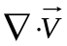> = 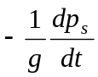 (1)
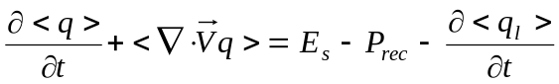 (2)
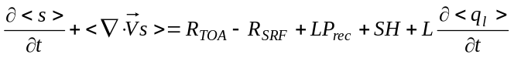 (3)
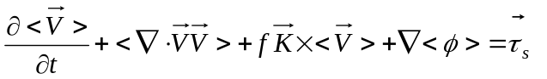 (4)

where
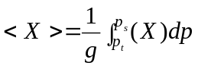
In the above, 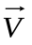is the wind, s = C_{p}T +gz is the dry static energy, q is the mixing ratio of water vapor, and p_{s} is the surface pressure. 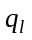 is the cloud liquid water content. R is the net downward radiative flux at TOA and at the surface (SRF), τ_{s} is the surface wind stress, P_{rec} is precipitation, L is the latent heat of vaporization, SH is the sensible heat flux, E_{s} is the surface evaporation, and p_{t} is the TOA pressure. Phase changes associated with ice are neglected for simplicity.
In the constrained variational analysis method, the atmospheric variables (, s, q) are forced to satisfy (1) – (4) with minimum adjustments to direct sounding measurements. The final analysis product is derived by minimizing the cost function:

, (5)

with (1) – (4) as strong constraints, where superscript “*” denotes the analyzed data and subscript “0” denotes direct measurements and α is the weighting function related with error estimates in the initial analysis.
During ARM IOPs at SGP, as illustrated in Fig. 2, the large-scale forcing data are derived from the constrained variational analysis using the upper-air input data measured from five ARM balloon sondes merged with those from seven NOAA wind profilers. RUC analyses are used as background fields. Fig. 3 shows locations of the ARM sounding stations, the NOAA wind profilers, the RUC analysis grids, and the twelve final analysis grids designed in Zhang et al. [2001]. The required constraints are obtained from the ARM surface and TOA measurements, which include (1) the Surface Meteorological Observation Stations (SMOS) that measure surface precipitation, surface pressure, surface winds, temperature and relative humidity; (2) the Oklahoma and Kansas mesonet stations (OKM and KAM) that measure surface precipitation, pressure, winds and temperature; (3) the Energy Budget Bowen Ratio (EBBR) stations that measure surface latent and sensible heat fluxes and surface broadband net radiative flux; (4) the MicroWave Radiometer (MWR) stations that measure the column precipitable water and total cloud liquid water; (5) the radar rainfall data obtained from the Arkansan Basin Red River Forecast Center (ABRFC) 4-km hourly WSR-88D radar precipitation estimates; and (6) the Geostationary Operational Environment Satellite (GOES) that measures clouds and broadband radiative fluxes (Minnis et al., 1995). The distribution of these instruments around the ARM SGP site can be seen in Fig. 5 in Zhang et al [2001]. Zhang and Lin [1997] showed that the large-scale forcing data set derived from the variational analysis is dynamically and thermodynamically consistent and the adjustments required to conserve the column integral budget of mass, moisture, energy, and momentum are comparable to uncertainties in the original measurements. Compared to the conventional analysis approach in which only a mass constraint was applied, the constrained variational analysis typically exhibits considerably smaller errors [Waliser et al., 2002]. The forcing data derived from the variational analysis have been used in most recent SCM and CSRM studies.
Long-term continuously observed upper-air input data (e.g., sondes) for deriving the large-scale forcing are not available in the observations. However, the ARM program has collected long-term continuous surface and TOA fluxes near its SGP site for the past several years. This provides the required column constrained variables for the variational analysis approach. To develop the multi-year long-term continuous forcing data, this study implemented a combined approach, in which the NWP (e.g., RUC) analyses are used to replace sondes as the required upper-air input data and the ARM surface and TOA flux measurements are used as the constraints in the constrained variational analysis. It should be noted that the forcing directly derived from NWP analyses is also dynamically and thermodynamically consistent. However, this consistent is achieved based on the model-calculated surface and TOA constraints, which are not the same as observations. In our approach, the atmospheric state variables from NWP analyses are adjusted to balance the observed column budgets. This is an important difference between the forcing directly derived from NWP analyses and the forcing derived from the current approach. In the following sections, we will show that using the surface and TOA observations to constrain the NWP state variables through the variational analysis approach can significantly improve the quality of derived large-scale forcing data.

3. RUC analyses
The atmospheric state variables obtained from the NOAA RUC-2 analyses have been used in developing the ARM long-term continuous forcing data set. The RUC is an operational atmospheric prediction system, including a numerical forecast model and an analysis system to initialize that model. It is used to assimilate recent observations aloft and at the surface to provide very high frequency updates of current conditions and short-range forecasts using a mesoscale model. The RUC provides hourly three-dimensional objective analyses over the contiguous United States with a 40 km horizontal resolution and 40 vertical sigma levels. The RUC analysis grids around the ARM SGP site are displayed in Fig. 3. More detailed description of the RUC analysis can be seen in Benjamin et al. [1998].
To examine the quality of the RUC analyses, Figure 4 shows the root-mean-square (rms) error of the atmospheric state variables from the RUC analyses (thin lines) during the ARM Summer 1997 IOP, the Spring 2000 IOP, and the late Fall 2000 IOP. These three IOPs are from Jun 18 (2330 UTC) to July 18 (2330 UTC), 1997; March 1 (1730 UTC) to March 22 (0830 UTC), 2000; and Nov 27 (1730 UTC) to Dec. 22 (0830 UTC), 2000, respectively. Also shown are the observed standard deviations of these fields (thick lines) during the three IOPs. It is seen that the observations show much larger temporal variations in the horizontal winds and the temperature fields and smaller temporal variability in the moisture in the Spring and Fall IOPs than those in the Summer IOP. RUC analyses typically capture well the temporal evolutions of the observed large-scale atmospheric state variables (not shown) with the rms error of typically less than 1 m s⁻¹ in the horizontal wind components, 0.5 K in the temperature, and 0.5 g kg⁻¹ in the moisture for the most part of the troposphere (Figs. 4a-d). The magnitude of the rms errors is comparable to the typical uncertainty in the observational measurements. It is noted that relatively larger errors are seen in the moisture field during the Summer IOP and in the temperature during the late Fall IOP. In comparison with the observed variability itself, it is worthy emphasizing that these errors in the RUC analyses are significantly smaller except for the moisture field during the Summer IOP, which shows errors are about 60 percent of the magnitude in the observed variability. This suggests improvement of moisture analyses during summertime is needed.

4. Evaluation of the ARM continuous forcing data with IOP observations
Similar to Xie et al. [2003], the ARM continuous forcing data developed from the NOAA RUC analyses using the approach described in section 2 are evaluated by those derived from the objective variational analysis [Zhang and Lin, 1997; Zhang et al., 2001] under three selected cases: a strong convective period from 23 June (2330 UTC) to 29 June (2330 UTC) during the Summer 1997 IOP (i.e., the same period as used in Fig. 1), a moderate precipitation period from 8 March (1730 UTC) to 18 March (1730 UTC) during the Spring 2000 IOP, and a non-precipitation period from 27 Nov. (1730 UTC) to 3 Dec. (1730 UTC) during the late Fall 2000 IOP. In this study, the forcing derived from the objective variational analysis is considered as the “observed” forcing. Uncertainties in the observed forcing data were discussed in Xie et al. [2003] for the Summer case. To address the impact of the ARM observed constraints on the derived forcing fields, we will also discuss the forcing derived from the RUC analyses with the mass constraint only. The latter can be roughly considered as the forcing data that are derived directly from the RUC analyses, which are not available in the current RUC analysis data set. In the following discussions, we use “RUC-C” to represent the experiment with the RUC analysis input data that applies all column budget constraints from the ARM observations, “RUC-NC” to represent the experiment with RUC analyses constrained by the column mass only, and ‘OBS’ to represent the experiment with the objective variational analysis.

4.1 Summer strong convective case
Figures 5a,b shows the derived omega fields from RUC-C and RUC-NC for the Summer case, respectively. The omega derived from OBS and the observed surface precipitation rates are shown in Fig. 1a. It is seen that even though both RUC-C and RUC-NC typically capture the bulk characteristics of the observed omega field, i.e., upward motions during the precipitation events and downward motions during the non-precipitation periods, RUC-C exhibits considerably better agreement with OBS compared to RUC-NC. The biggest improvements are seen during two strong precipitation periods where RUC-NC produces the omega that is much weaker than OBS. Moderate improvements made by RUC-C are also seen in other periods compared to RUC-NC, for example, RUC-C correctly reproduces the observed downward motions at the middle of day 1 (although a little weak) while RUC-NC generally shows upward motions during the time.
Significant improvements can also been seen in the derived large-scale temperature and moisture forcing fields, i.e., the total advective tendencies of temperature and moisture, from the RUC analyses with the ARM constraints. Noted that the adiabatic compression/expansion term is included in the temperature forcing. Figure 6 shows a scatter plot of these derived forcing fields at all vertical levels between RUC-C and OBS and between RUC-NC and OBS. With the ARM constraints, RUC_C captures well the observed temperature and moisture forcing fields in both the magnitude and the temporal variability. It just slightly underestimates the observed advective cooling (Fig. 6a) when the cooling is strong (> 20 k day⁻¹). In contrast, the underestimation is significantly larger in that derived from RUC-NC (Fig. 6c). Similar results can be seen in the moisture forcing (Figs. 6b,d). In addition, RUC-C shows much higher correlation with OBS in these derived forcing fields than RUC-NC. Examination of the correlation as a function of height shows that the correlation for the temperature forcing between RUC-C and OBS is larger than 0.8 at all vertical levels (larger than 0.95 at the levels above 615 hPa) and the correlation for the moisture forcing is typically larger than 0.7 for the levels below 465 hPa. These are significantly larger than the correlations between RUC-NC and OBS. The weaker correlation in the moisture forcing between RUC-C and OBS compared to that in the temperature forcing could be due to the relatively larger errors in the moisture from the RUC analyses as shown in Fig. 4d.
To quantify the error arisen from using the RUC analyses, Figure 7 shows the rms error of the derived forcing fields from RUC-C and RUC-NC. The rms error of the RUC-C derived forcing fields is within 3 hPa hr⁻¹ for the omega field, 3 k day⁻¹ for the temperature forcing, and 4 g kg⁻¹ day⁻¹ for the moisture forcing, for this Summer case. These are slightly larger than the uncertainty in the observed forcing data due to instrument and measurement errors in the upper-air data (sondes), which is within 1 hPa hr⁻¹ for the omega field, 2 k day⁻¹ for the temperature forcing, and 1 g kg⁻¹ day⁻¹ for the moisture forcing as shown in Xie et al. [2003]. However, these errors are much less than those in the RUC-NC derived forcing data. It is also noted that the forcing data from RUC-C have the rms errors that are considerably smaller than the observed temporal variability itself (STD-OBS) except for the moisture forcing, which shows relatively large errors in the lower troposphere. In contrast, the forcing data derived from RUC-NC exhibit much larger rms errors, which are of nearly the same magnitude as the observed variability.
The above results clearly show that with the observed column constraints, especially the heat and moisture constraints, the variational analysis can dramatically improve the large-scale forcing fields that are derived from the RUC analyses, especially during strong precipitation periods where the constraints are strong. These results also suggest that improvement of the quality of the RUC analyses is needed, particularly for the moisture field, in order to further improve the continuous forcing data set during the summer convective season.

4.2 Spring moderate precipitation case
Figure 8 compares the derived omega from RUC-C and RUC-NC with OBS for the Spring moderate precipitation case. The thick line in Fig. 8a is the surface precipitation rates observed during this period. It is seen that the Spring case contained one precipitation event on days 1-2 and one multi-day precipitation event on days 7-10. These precipitation events are mainly associated with large-scale stratiform clouds. Associated with these precipitation events, strong upward motions are seen in the observed omega field (Fig. 8a). Similar to the Summer case, without the observed column heat and moisture constraints, RUC-NC (Fig. 9c) produces weaker and smoother upward motions than the observed. It also shows weaker temporal variability compared to the observations. Corresponding to the first precipitation event on days 1-2, for example, the observed omega shows two peaks with one around 715 hPa and the other one around 515 hPa. The first peak is related to the very weak precipitation that occurred at the end of day 1 and the second peak is associated with the precipitation peak in the middle of day 2. This observed structure is smoothed by the omega derived from RUC_NC, which only shows a single peak in its produced omega field. These problems are significantly reduced in RUC-C when the observed column heat and moisture constraints are used (Fig. 8b). The magnitude and temporal variations of the observed omega field are well reproduced by RUC-C.
Fig. 9 shows the same information as Fig. 6 except for the Spring case. Analogous with the omega, RUC-C produces the temperature and moisture forcing data that have considerably better agreement with OBS than RUC-NC. The correlation between the RUC-C and the OBS derived forcing fields is dramatically high. For the temperature forcing, the correlation is larger than 0.95 for the most of the troposphere except for the levels above 265 hPa where the facing itself is weak. For the moisture forcing, the correlation is larger than 0.9 in the levels below 465 hPa. Above the level, the moisture forcing is very small. It should be noted that, when the forcing itself is very small, any small difference between the two types of forcing data could have significant impacts on the correlation.
The rms error of these derived forcing data for the Spring case is shown in Fig. 10. It is seen that the analysis errors from RUC-C are about 1 hPa hr⁻¹ in the omega, 2.5 K day⁻¹ for the temperature forcing, and 1 g kg⁻¹ day⁻¹ for the moisture forcing, respectively. These are comparable to the uncertainties in the observed forcing data due to instrument and measurement errors in the sounding input data as discussed in Xie et al. [2003], and significantly smaller than the observed variability. The better results for the Spring case compared to the Summer case is partly because the RUC analyses show smaller errors (relatively to the observed variability) in the Spring case than the Summer case (Fig. 4), especially for the moisture analyses. It is interesting to see that the analysis errors from RUC-NC in the Spring case are also smaller than those in the Summer case. The magnitude of the rms error of the RUC-NC derived forcing is just around 50 percent of the magnitude of the observed variability. This is consistent with the ECMWF model-derived forcing data. Xie et al. [2003] found that the ECMWF forcing and the observed forcing show much better agreement in the Spring case than the Summer case.

4.3 Fall non-precipitation case
In above discussions, we have shown that the ARM observed column constraints can significantly improve the quality of the derived large-scale forcing data from the RUC analyses using the constrained variational analysis in a strong summer convective period and a moderate spring large-scale dominated precipitation period. The largest improvements are seen over periods where precipitation events were observed. In this subsection, we will examine whether improvements can still be obtained in non-precipitation periods where the column heat and moisture constraints are relatively weak, in absence of precipitation. As shown in Fig. 11a, the selected Fall case was a dry period and this period was mainly dominated by the large-scale downward motions. Compared to the Summer and the Spring cases, the derived omega from OBS during the non-precipitation period is weaker. In general, both RUC-C and RUC-NC capture the observed omega well although they all somewhat underestimate the observed downward motions (Figs. 11b,c). An encouraging result is that RUC-C still displays noticeably better agreement in the derived omega with OBS than RUC-NC during the quiet period. The problem of underestimation of the observed downward motions on day 2 and days 5-6 and the upward motions on day 3 in RUC-NC is clearly reduced in RUC-C, which produces the vertical motions that are of nearly the same magnitude as the observed values.
Same as Fig. 6 and Fig. 9, Fig. 12 shows the correlation between RUC-C and OBS and between RUC-NC and OBS in the derived temperature and moisture forcings. While both RUC-C and RUC-NC reproduced well the observed forcing, RUC-C shows moderate improvements in the temperature forcing, consistent with the improvements in the omega field. There is no clear improvement seen in the derived moisture forcing.
Similar results can be seen in the rms error plots (Figs. 13a-c). With the ARM observed constraints, RUC-C shows a moderate improvement in the derived temperature forcing (Fig. 13b), a slight improvement in the omega field (Fig. 13a), and almost no improvement in the moisture forcing (Fig. 13c), compared to RUC-NC.

5. Impacts on SCM simulations
We showed in the last section that the continue forcing data derived from the RUC analyses using the variational analysis approach constrained with the ARM surface and TOA measurements agree well with the observed forcing during the three selected IOPs. However, small differences, which are expected, are seen between these two forcing data due to errors in the RUC analyses and uncertainties in the sounding measurements. In this section, we will use the NCAR CCM3 SCM [Hack et al., 1998] with a modified cumulus convection scheme [Xie and Zhang, 2000] to investigate how the difference between the two types of forcing data affects SCM simulations. We will focus on whether the SCM driven by the continuous forcing can produce simulations that are similar to those from the SCM driven by the observed forcing so that the same model deficiencies can be detected by using the continuous forcing data as those detected by using the observed forcing data.
In the SCM runs, the large-scale total temperature and moisture forcings are specified from the two different forcing datasets and the surface forcing is calculated by the model surface parameterizations. The prognostic land variables used in the CCM3 land surface model are initialized using climatological values if there are no observations. The model is run for a 36-hour forecast every day to avoid serious drift of SCM simulations shown in other SCM studies [e.g., Ghan et al., 2000]. For each forecast, the temperature and moisture are initialized with the observations. A composite of 12-36 hour forecasts from the series of 36-hour runs is analyzed. For the convenience of discussion, we use SCM-OBS to represent the SCM run with the observed forcing and SCM-RUC-C to represent the run with the continuous forcing in the following discussions. We will not show results from the SCM driven by the forcing derived from RUC-NC, which generally shows much larger simulation errors than those using the continuous forcing.
Figures 14 and 15, respectively, show the SCM simulated temperature and moisture biases driven by the two forcing datasets during the three selected periods. In general, both runs produce comparable simulation results with the temperature biases less than 6 K and moisture biases less than 4 g kg⁻¹, for the most of the periods and the model levels. The temperature biases are generally comparable for the three cases while the moisture errors are considerably smaller for the Spring and Fall cases than the Summer case. The latter shows quite large moist biases near the surface and dry biases in the lower and middle troposphere (Fig. 16a). This may reflect model deficiencies in vertically transporting moisture from surface to troposphere during strong convective periods. Another important feature shown in the figures is that the distribution of the model simulation errors is quite similar between these two runs, especially for the Fall and Spring cases. The biases produced by these two forcing data are well correlated for the most of the model levels.
Figures 16a,b compare the simulated surface precipitation rates of the two runs during the Summer and Spring periods, respectively. It is encouraging to see that the simulated surface precipitation rates produced by SCM-RUC-C and SCM-OBS agree considerably well with each other for both cases. The temporal correlations between the two simulated precipitation rates are 0.91 for the Summer case and 0.97 for the Spring case, respectively. For the Summer case, both SCM-OBS and SCM-RUC-C produce spurious precipitation on day 1 and overestimate the observed precipitation at the end of day 5 and the end of day 6 while they both underestimate the observed peak at the beginning of day 6. For the Spring case, both runs reproduced dramatically well the observed precipitation events. Similar results are seen in other important atmospheric fields, such as the column precipitable water, the surface and TOA shortwave fluxes, and the surface latent and sensible heat fluxes. These fields typically show rather high temporal correlation (> 0.90) between SCM-OBS and SCM-RUC-C, particularly for the Spring and Fall cases.
Compared to these fields, relatively larger differences can be seen in the cloud related fields (e.g., the cloud amount and cloud liquid water) simulated by the SCM with the two different forcing data. As an example, Fig. 17 compares the simulated total cloud amounts (CLD) with the NOAA GOES satellite clouds. Considerable differences are seen between the simulations and the observations, and between the two runs. This illustrates the sensitivity nature of the model clouds. It should be noted that the cloud amount is a diagnosed variable in the CCM3 [Kiehl et al., 1996]. It is sensitive to small differences in the model-predicted relative humidity, atmospheric stability, convective precipitation rate, and the prescribed vertical velocity from the forcing datasets. Nevertheless, the simulated clouds from SCM-RUC-C still show a fairly good correlation with those produced from SCM-OBS. The coefficients are 0.63, 0.76, and 0.51 for the Summer case, the Spring case, and the Fall case, respectively. In addition, both runs show similar model error in simulating the observed cloud field, i.e., both runs tend to overestimate the observed cloud amounts for all the three cases. Similar results can be seen in the simulated cloud liquid water path, for which both runs significantly underestimate the observed values during precipitation periods (not shown).
The similar results obtained by the SCM forced with the continuous forcing and the observed forcing in simulating the detailed time evolution of these important atmospheric fields provide confidence in using the continuous forcing data for statistical study of SCM simulations over a much longer time period. The statistics of SCM simulations should further reduce the sensitivity of SCMs to the difference between the continuous forcing and the observed forcing.

6. Summary and discussion
In this study, we have proposed an alternative approach to develop the multi-year long-term continuous SCM/CSRM forcing data from NWP analyses by using the variational analysis approach constrained with the observed surface and TOA measurements. The derived forcing data from the RUC analyses using this approach have been evaluated by those derived from sondes and wind profilers using the objective variational analysis under three selected ARM IOP cases. We have shown that the forcing data derived from the RUC analyses constrained with the ARM surface and TOA observations exhibit considerably better agreement with the observed forcing than those derived from the RUC analyses without these constraints. The improvements tend to be the greatest during precipitation periods. During non-precipitation periods, the improvements are moderate due to relatively weak constraints in absence of precipitation. In general, the agreement between the continuous forcing and the observed forcing is better for the Spring and Fall cases than the Summer strong convective case. The agreement in the derived omega and temperature forcing fields between these two data sets is better than that in the derived moisture forcing, especially during the Summer case. This is partly related to the relatively larger errors in the RUC moisture analyses. This suggests an improvement of the RUC moisture analyses is needed in the future.
It has been shown that the SCM driven by the continuous forcing is able to produce similar simulations in most atmospheric fields as those obtained in the SCM driven by the observed forcing for the three cases. Relatively larger sensitivity to the difference between these two different forcing data sets is seen in those fields that are associated with clouds. Nevertheless, some SCM errors related to clouds can still been detected by using the continuous forcing data. For example, the problem of overestimating the observed cloud amounts produced by the SCM with the observed forcing is also shown in the SCM with the continuous forcing. The sensitive nature of the model clouds expects to be reduced when a prognostic cloud scheme is used in the future.
It should be noted that the forcing derived from the RUC analyses cannot expect to be exactly the same as those derived from the observations due to errors in the RUC analyses and uncertainties in the observations. However, this study has shown that adjusting the RUC analyses to conserve the observed column budgets of mass, heat, moisture, and momentum can significantly improve the quality of the derived forcing data from the RUC analyses. The encouraging results from the SCM tests further provide confidence in using the developed continuous forcing data for statistical study of SCM simulations over long-time periods.
The results presented in this study can be viewed as a base case in our efforts to develop the ARM long-term continuous forcing data. Currently a one-year continuous forcing data using the proposed approach have been developed for the year 2000 and have been used in the some SCM/CSRM studies. For example, Del Genio and Wolf [2003] used the continuous forcing data to study the response of different cloud types to changes in large-scale temperature and moisture forcings in different dynamical regimes. Further improvements to the continuous forcing data are currently under consideration. These include improvements in both the variational analysis approach and the quality of the upper-air input data. For the variational analysis, for example, we could further improve analysis results by properly defining those weighting functions specified in the cost function (Eq. 5) based on systematic errors (if known) in the RUC analyses so that adjustments can be adequately done for different state variables in the analysis. To improve the upper-air input data, we will incorporate those observations and remote sensing retrievals that are available at the ARM SGP site over long periods of time. These could include 1) the NOAA wind profiler data that could be used to improve the RUC horizontal winds; 2) the high frequency temperature and moisture retrievals from the atmospheric emitted radiance interferometer (AERI) [Feltz et al., 2003] that could be used to improve the RUC temperature and moisture analyses within the boundary layer; 3) the six-hourly sondes at the central facility of the ARM SGP site; and 4) the moisture retrievals from the Raman Lidar at the central facility of the ARM SGP site. Studies and experiments to incorporate these data are being conducted and results will be reported separately.

Acknowledgements. This research was performed under the auspices of the U. S. Department of Energy by the University of California, Lawrence Livermore National Laboratory under contract No. W-7405-Eng-48. Work at SUNY Stony Brook was supported by ARM grant DE-FG02-98ER62570 and was also supported by NSF under grant ATM9701950. The developing continuous forcing effort has been strongly supported by the ARM Cloud Parameterization and Modeling working group.
References
Barnes, S. L., A technique for maximizing details in numerical map analysis, J. Appl. Meteor., 3, 396-409, 1964.
Bechtold, P., et al., A GCSS model intercomparison for a tropical squall line observed during TOGA-COARE, II: Intercomparison of single-column models and a cloud-resolving model. Q. J. R. Meteorol. Soc., 126, 8665-888, 2000.
Benjamin S. G. et al., RUC-2 – The Rapid Update Cycle Version 2. NWS Technical Procedures Bulletin 448, NOAA/NWS, 18 pp., National Weather Service, Office of Meteorology, Silver Spring, Maryland, 1998. (Available at http://205.156.54.206/om/448.htm)
Cripe, D., Single-Column Modeling: sensitivity to initial conditions and divergence forcing, in Proceedings of the Seventh Atmospheric Radiation Measurement (ARM), Science Team Meeting, CONF-970365, US Department of Energy, Washington, D. C, 1998.
Del Genio, A. D., and A. B. Wolf, Single-column model simulation of cloud sensitivity to forcing. The Thirteenth ARM Science Team Meeting Proceedings, Broomfield, Colorado, 2003.
Feltz, W. F., et al., Near continuous profiling of temperature, moisture, and atmospheric stability using the Atmospheric Emitted Radiance Interferometer (AERI), J. Appl. Meteor., 42, 584-597, 2003.
Ghan, S. J., et al., An intercomparison of single column model simulations of summertime midlatitude continental convection. J. Geophys. Res., 105, 2091-2124, 2000.
Hack, J. J., and J. A. Pedretti, Assessment of solution uncertainties in single-column modeling frameworks, J. Clim., 13, 352-356, 2000.
Lin, X., and R. H. Johnson, Kinematic and thermodynamic characteristics of the flow over the western Pacific warm pool during TOGA COARE, J. Atmos. Sci., 53, 695-715, 1996.
Kiehl, J. T., et al., ‘Description of the NCAR Community Climate Model (CCM3)’. NCAR Technical Note, NCAR/TN-420+STR. National Center for Atmospheric Research, Boulder, CO, USA, 1996.
Randall, D. A., K-M. Xu, R. J. C. Somerville and S. Iacobellis, Single-column models and cloud ensemble models as links between observations and climate models. J. Climate, 9, 1683-1697, 1996.
Redelsperger, J.-L., et al., A GCSS model intercomparison for a tropical squall line observed during TOGA-COARE. Part I: CRM results. Q. J. R. Meteorol. Soc. 126, 823-863, 2000.
Waliser, D. E., J. A. Ridout, S. Xie, and M. Zhang, Variational objective analysis for atmospheric field programs: a model assessment. J. Atmos. Sci., 59, 3436-3456, 2002.
Xie, S. C., and M. H. Zhang, Impact of the convective triggering function on single-column model simulations. J. Geophys. Res., 105, 14983-14996, 2000.
Xie, S. C., et al., Intercomparison and evaluation of cumulus parameterizations under summertime midlatitude continental conditions. Q. J. R. Meteorol. Soc., 128, 1095-1135, 2002.
Xie, S. C., R. T. Cederwall, M. Zhang, and J. Yio, Comparison of SCM and CSRM forcing data derived from the ECMWF model and from objective analysis at the ARM SGP. J. Geophys. Res., Accepted, 2003.
Xu, K.-M. et al., An intercomparison of cloud-resolving models with the Atmospheric Radiation Measurement summer 1997 Intensive Observation Period data. Q. J. R. Meteorol. Soc., 128, 593-624, 2002.
Zhang, M. H., and J. L. Lin, Constrained variational analysis of sounding data bases on column-integrated budgets of mass, heat, moisture, and momentum: Approach and application to ARM measurements. J. Atmos. Sci., 54, 1503-1524, 1997.
Zhang, M. H., J. L. Lin, R. T. Cederwall, J. J. Yio, and S. C. Xie, Objective analysis of ARM IOP Data: Method and sensitivity. Mon. Weather Rev., 129, 295-311, 2001.

Figure Captions

Figure 1. (a) The derived vertical velocity (omega) from the objective variational analysis (OBS) for the selected precipitation period during the Summer 1997 IOP. Contour interval is 5. Contours less than 0 are shaded. In the figures, solid lines are for contours greater than or equal to zero and dotted lines for contours less than zero. (b) Same as (a) except for the omega derived from the ECMWF model. Thick solid lines in (a) and (b) are the observed and ECMWF model-produced surface precipitation rates (mm day⁻¹), respectively. (c) Time series of the observed (solid), ECMWF produced (solid line with filled circle), and the SCM simulated surface precipitation rates (mm day⁻¹). Dotted line is for using the ARM variational forcing and dotted line with unfilled square for using the ECMWF forcing.

Figure 2. A diagram that illustrates the approach used to derive the long-term continuous forcing using the RUC analyses constrained by the ARM observations. Circles enclosed by dashed lines are for the data that are not available or not used in developing the continuous forcing data.

Figure 3. The locations of the ARM five sounding balloons (↑), the seven NOAA wind profilers (), the RUC analysis grids (+), and the SCM variational analysis domain (•) at the ARM SGP site.

Figure 4. The errors in the RUC analyses of (a) horizontal wind u-component, (b) v-component, (c) temperature, and (d) moisture during the ARM Summer 1997 IOP, Spring 2000 IOP, and Fall 2000 IOP. Thin lines show the rms difference between the RUC analyses and the ARM observations. Thick lines represent standard deviations of the observed values.

Figure 5. Same as Figure 1a except for the derived omega from (a) the RUC analyses with the ARM constraints (RUC-C) and (b) the RUC analyses with the mass constraint only (RUC-NC).

Figure 6. Scatter plots of the derived temperature and moisture forcing data at all vertical levels from RUC-C (a, b) and RUC-NC (c, d) for the selected precipitation period during the Summer 1997 IOP.

Figure 7. The rms difference between the derived forcing data from RUC-C and OBS (dotted lines) and form RUC-NC and OBS (dashed lines) for the selected precipitation period during the Summer 1997 IOP. Solid lines show the standard deviations of the observed forcing data. (a) The vertical velocity. (b) The temperature forcing. (c) The moisture forcing.

Figure 8. The derived omega from (a) OBS, (b) RUC-C, and (c) RUC-NC for the selected moderate precipitation period in the Spring 2000 IOP. Contour interval is 5. Contours less than 0 are shaded. In the figures, solid lines are for contours greater than or equal to zero and dotted lines for contours less than zero. Thick solid line in (a) is the observed surface precipitation rates (mm day⁻¹).

Figure 9. Same as Figure 6 except for the selected moderate precipitation period in the Spring 2000 IOP.

Figure 10. Same as Figure 7 except for the selected moderate precipitation period in the Spring 2000 IOP.

Figure 11. Same as Figure 8 except for the selected non-precipitation period in the Fall 2000 IOP.

Figure 12. Same as Figure 6 except for the selected non-precipitation period in the Fall 2000 IOP.

Figure 13. Same as Figure 7 except for the selected non-precipitation period in the Fall 2000 IOP.

Figure 14. The time-height distributions of differences between the simulated temperature and the observations. The left panels (a, c, e) show the biases produced by the SCM with the OBS derived forcing (SCM-OBS) and the right panels (b, d, f) show the biases produced by the SCM with the RUC-C derived forcing (SCM-RUC-C), respectively. Contour interval is 2. Contours less than zero are shaded. In these figures, solid lines are for contours greater than or equal to zero and dotted lines for contours less than zero.

Figure 15. Same as Figure 14 except for the moisture biases; contour interval is 1.

Figure 16. The time series of the observed (solid) and the SCM simulated surface precipitation rates (mm day⁻¹). (a) Over the strong convective period in 1997 Summer IOP. (b) Over the moderate precipitation period in 2000 Spring IOP. Dotted line is for SCM-OBS and dashed line for SCM-RUC-C.

Figure 17. The time series of the observed and the SCM simulated total cloud amounts (%) (a) Over the strong convective period in 1997 Summer IOP. (b) Over the moderate precipitation period in 2000 Spring IOP. (c) Over the non-precipitation period in 2000 Fall IOP. Solid line is for the observations. Dotted line is for SCM-OBS and dashed line for SCM-RUC-C.

.

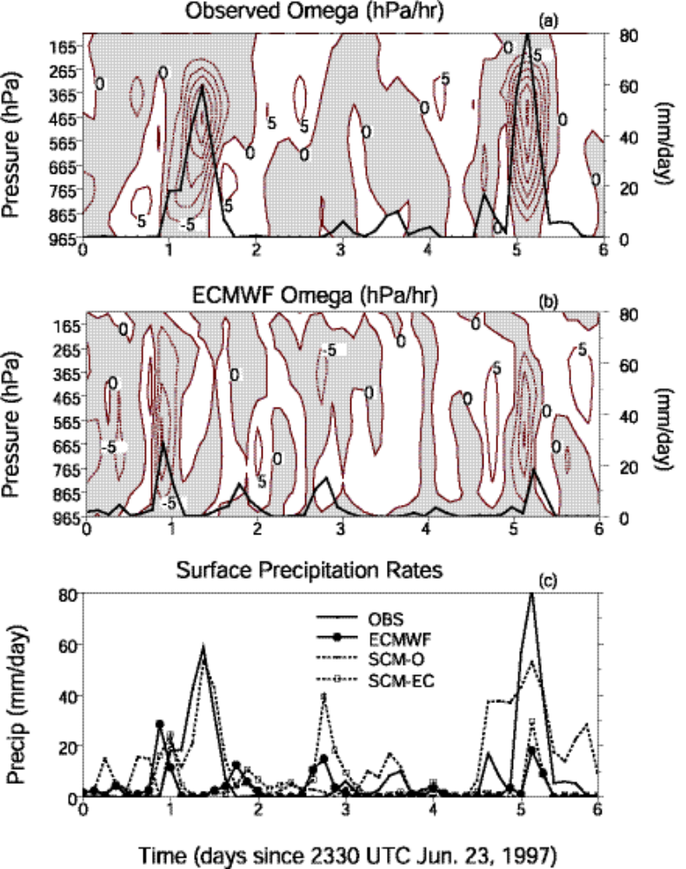

Fig. 1

Constraints
Surf. & TOA measurements
Variational Analysis
Derived Forcing Data
Sondes
OKM & KAM
Mesonet
SMOS

EBBR
Upper-air input Data
u,v,T,q
RUC

MWR

Wind Profilers
Radar Precip
GOES

Fig. 2

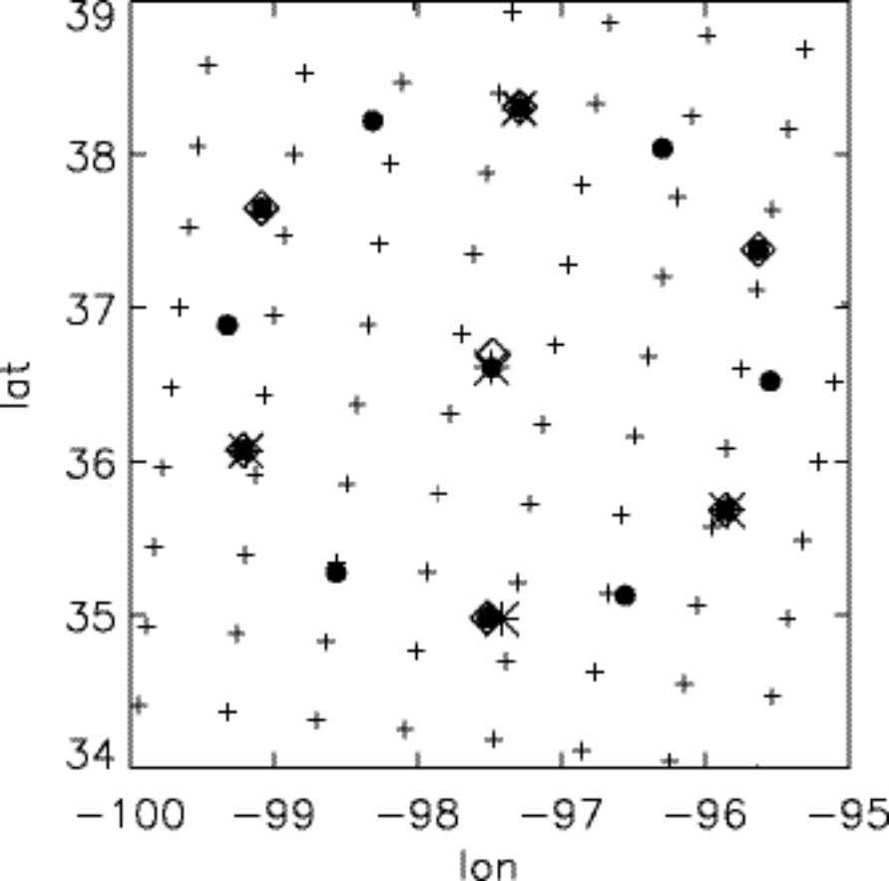

Figure 3

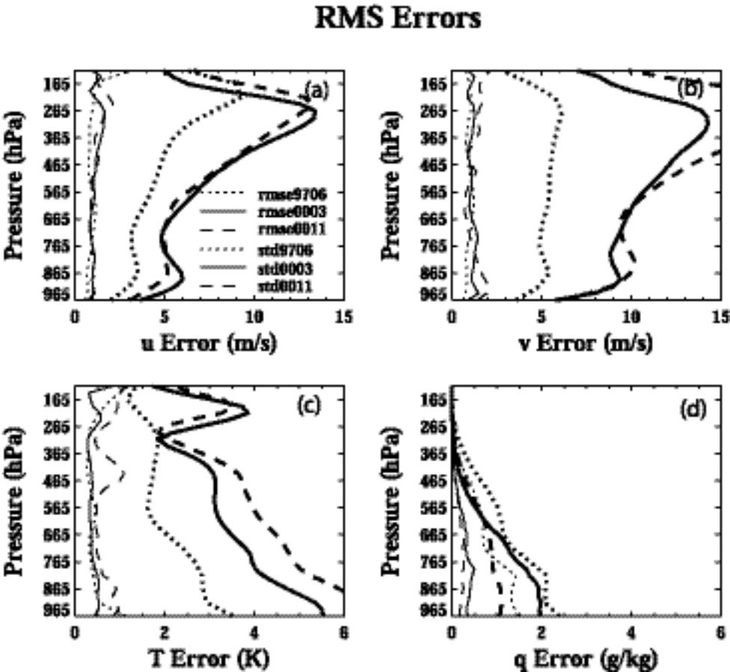

Fig. 4

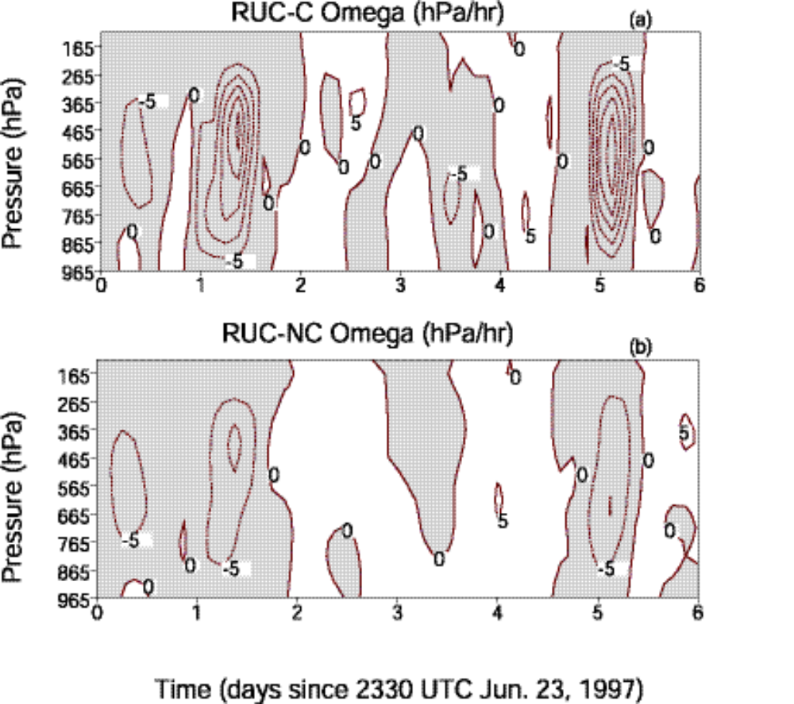

Fig. 5
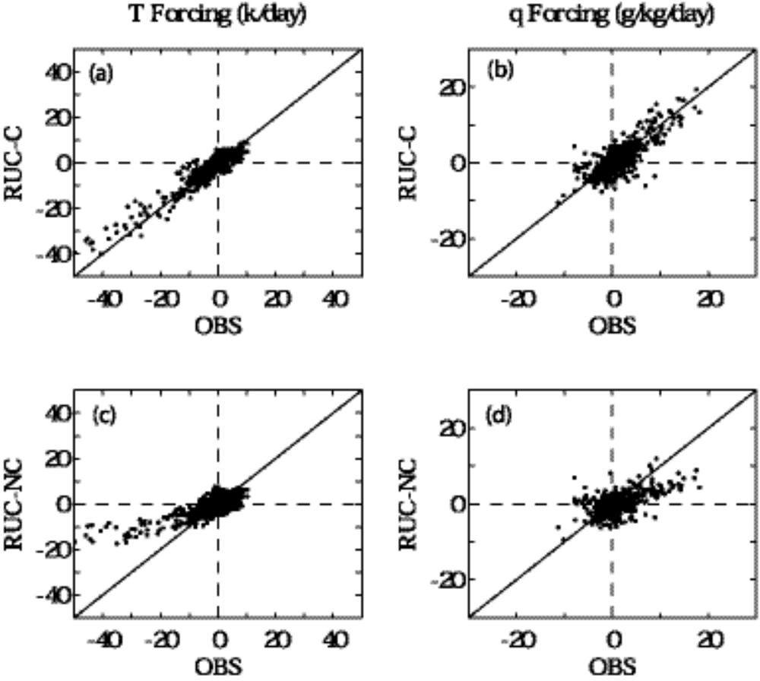

Fig. 6

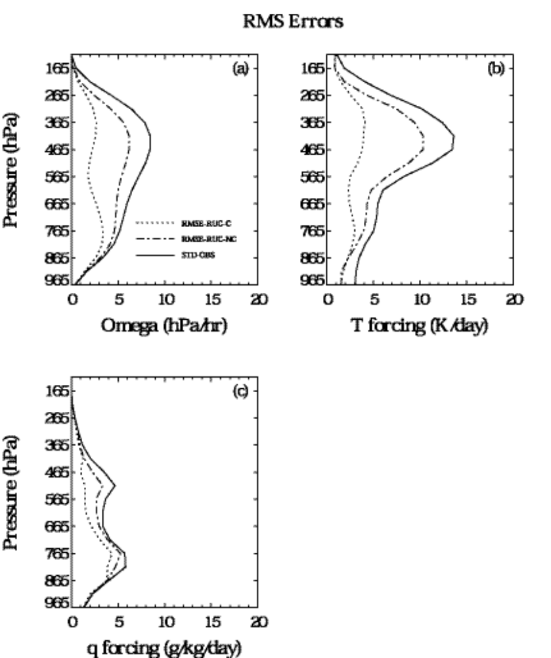

Fig. 7

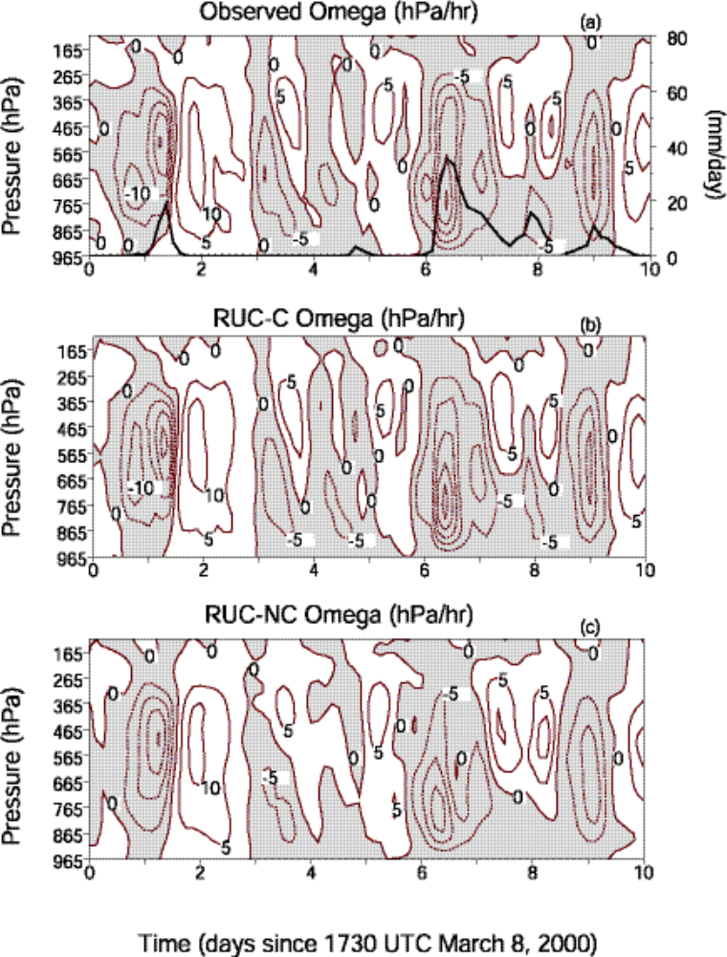
Fig. 8
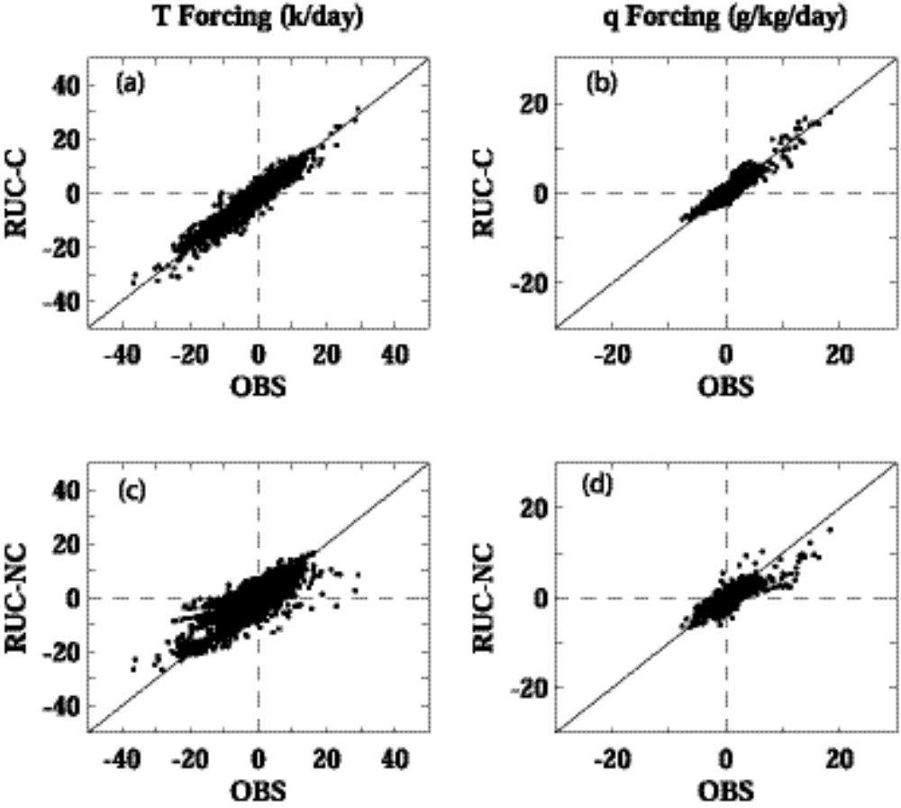

Fig. 9

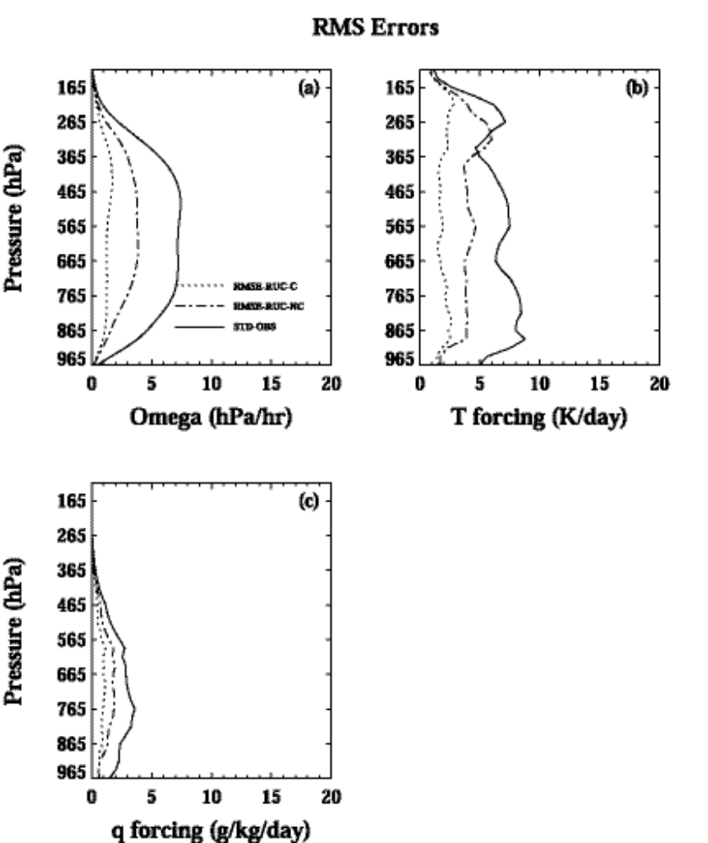

Fig. 10

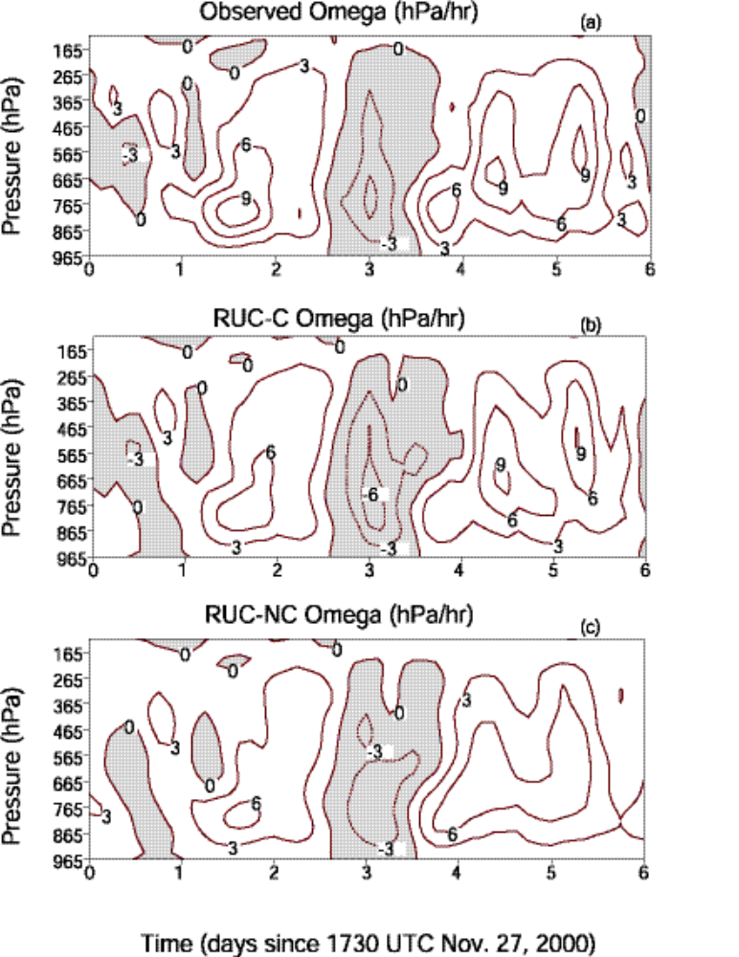
Fig11
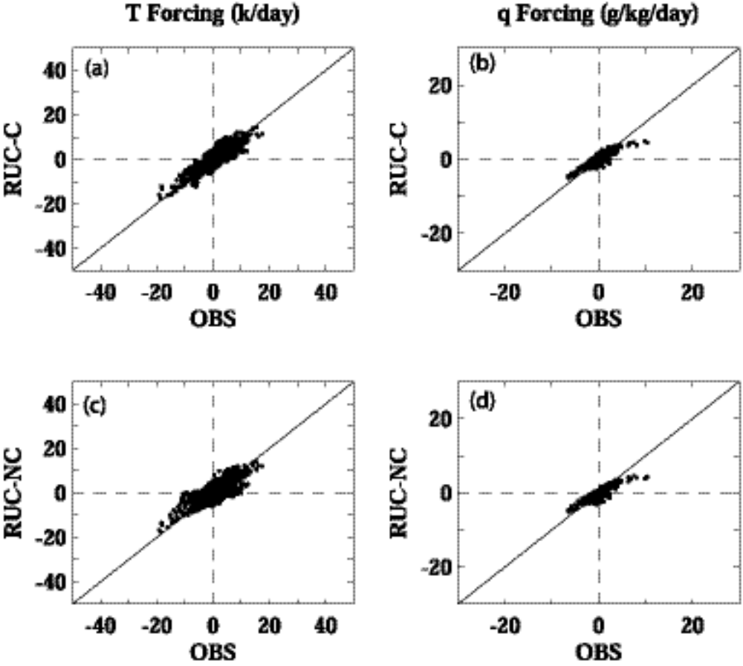

Fig.12

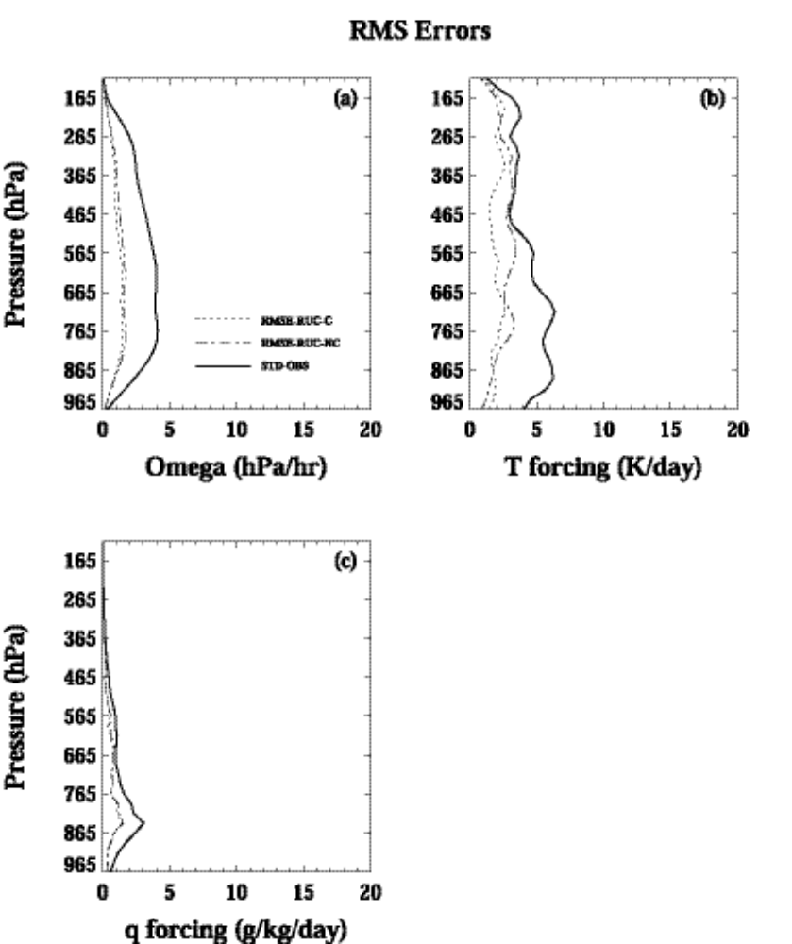

Fig. 13
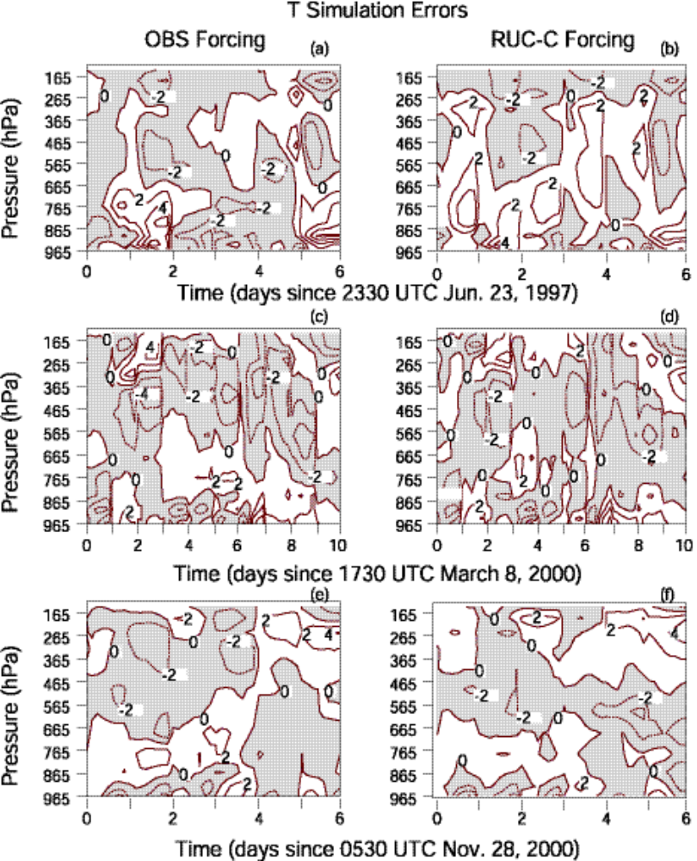
Fig. 14
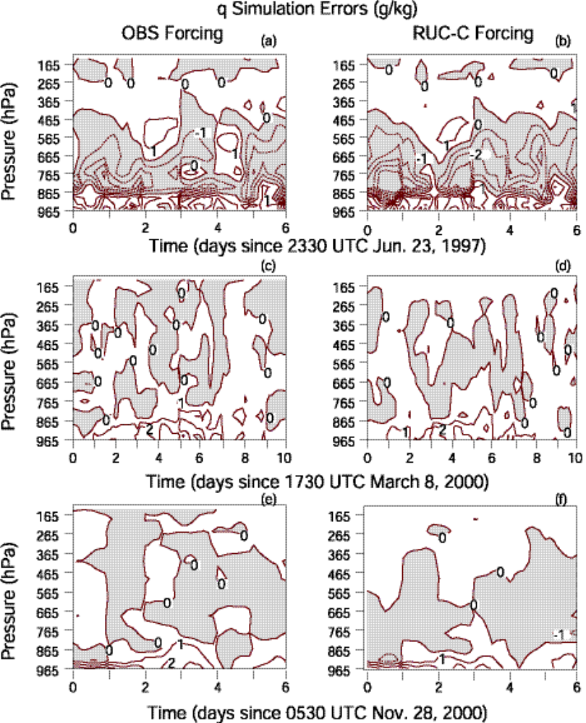
Fig. 15
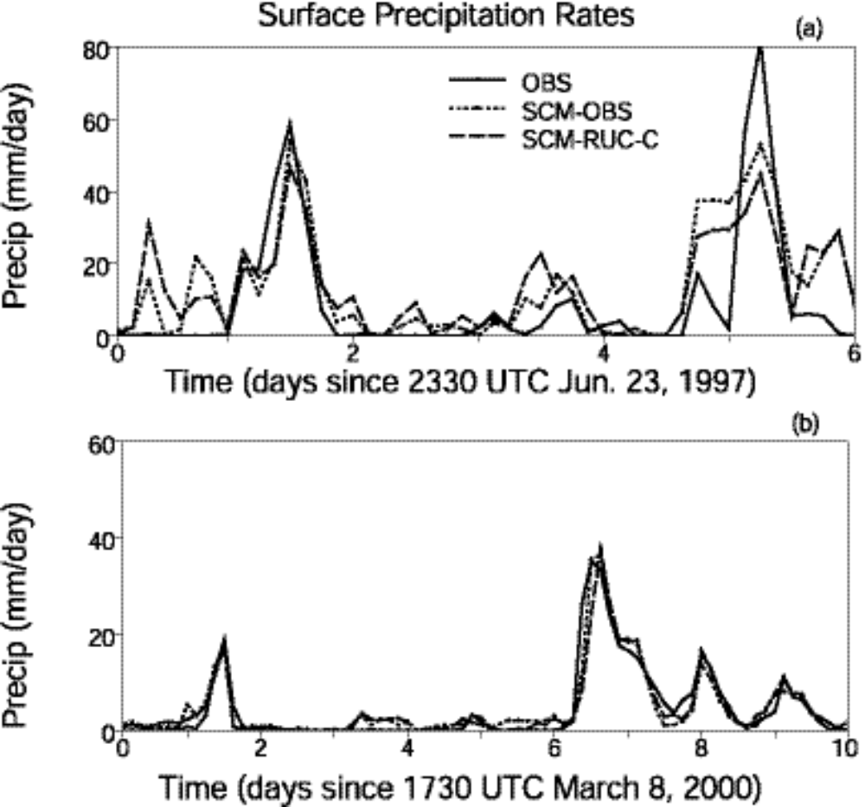

Fig. 16
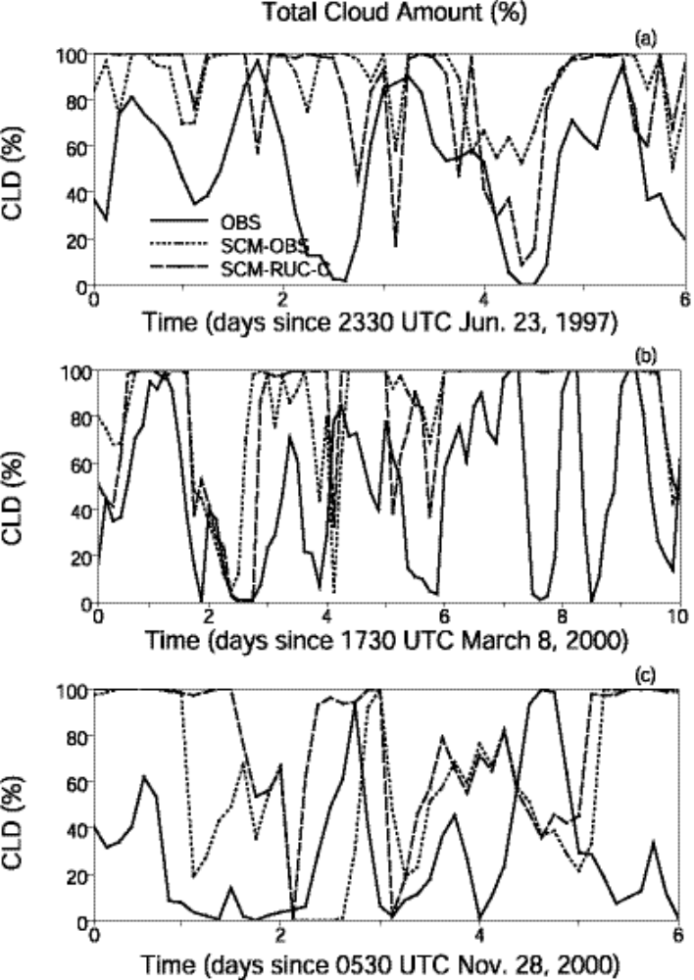
Fig. 17

Atmospheric Radiation Measurement program.
Tropical Ocean-Global Atmosphere Coupled Ocean-Atmosphere Response Experiment.

